Hardware Report  
 Week 2  
Fergus Williams

This week we have experimented with heights to get the best view with our camera, to make the software side of the line-following to occur easier. The field of view we found worked best was when the camera was fairly high up, near the highest it could go with our current arm setup.

Last week’s goals :  
This week we have been deciding on the placing of the battery in the robot – and have been largely considering placing the battery underneath the pi. This will remove the danger of it touching delicate circuitry, as well as giving increased stability from the lower centre of gravity.

We have also been working on concepts for a new wheel, as the roller we have been using for our back wheel has been causing slight drag issues that have been affecting the movement of our bot, and we feel this must be minimised so as to reduce chance of a catastrophic course-change during running. As these drag issues have been caused by the discs of the “wheel” locking up, we will be looking at such options as a rolling ball, or simply a round, dragging support so as to minimise the pulling off-centre.  
As our bot is front wheel driven, we do not require the back wheels to turn, only for support.

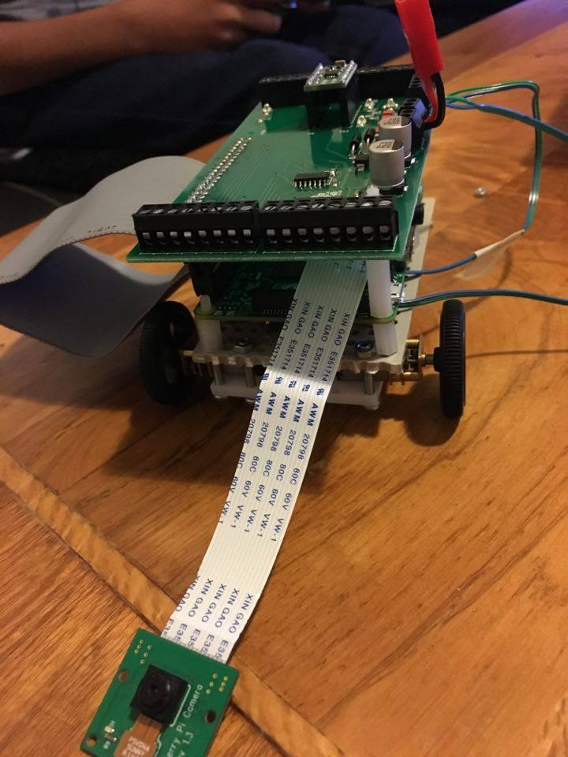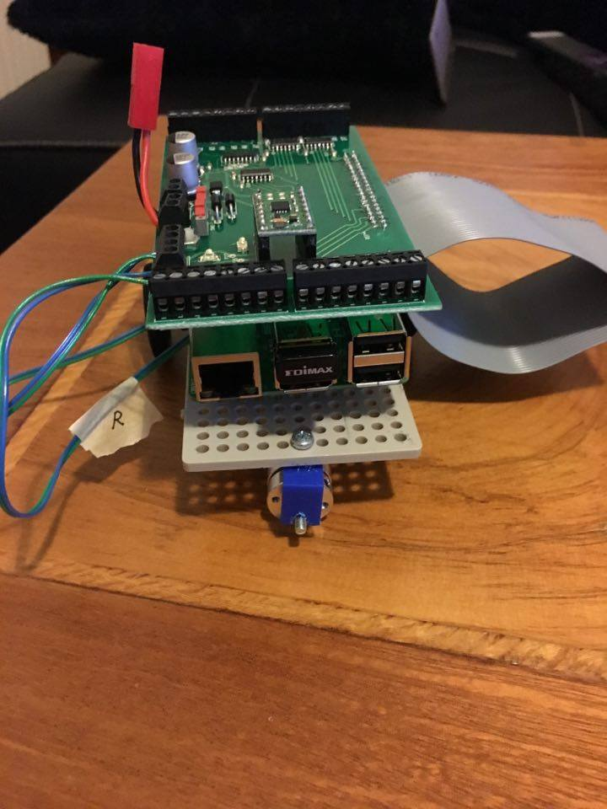

(Left – the problematic roller) (Right – the total length of camera cable available to use)

Next week, we will be printing a shell for our pi using Freecad, to keep all the components together in an aesthetic (but efficient) way. This shell should be as environmentally friendly as possible (using minimal resources, and being as recyclable as it can be), and should connect the entire body of the pi, as well as the lower chassis connecting the wheels. This will aid in keeping the battery in place, as well as preventing damage to our pi.